AIMLCZG549 — API-driven Cloud Native Solutions
Assignment I — Cloud-Native ML Application
Predicting Student Dropout & Academic Success
Dataset: UCI Predict Students' Dropout and Academic Success (4,424 records, 36 features, binary Dropout-vs-not target).

Group Details
Group No: ______
Sl. No | BITS ID | Name | Contribution (Qualitative) | % Contribution
1
2
3
4
5
6

1. Business Understanding
Higher-education institutions lose revenue and reputation when students drop out. Using academic, demographic and socio-economic attributes recorded at enrollment and after the first two semesters, this application predicts whether a student will Dropout, remain Enrolled, or Graduate — enabling early intervention by academic advisors.
- Problem type: multi-class classification (3 classes).
- Source: UCI ML Repository, dataset #697.
- Records: 4,424 | Features: 36 | Target: Dropout / Enrolled / Graduate.

2. Sub-Objective 1 — Data Pipeline (8 marks)

2.1 Data Ingestion
The semicolon-delimited CSV downloaded from the UCI repository is loaded with pandas (data_pipeline.ingest_data). Column headers are stripped of trailing whitespace. The pipeline confirms 4,424 rows × 37 columns on ingestion.
[INSERT SCREENSHOT: terminal output of `python data_pipeline.py` showing the 'Ingested 4424 rows' log line]
(replace this line with your captured screenshot)

2.2 Data Pre-processing
Implemented in data_pipeline.preprocess_data:
- Summary statistics for all columns saved to reports/summary_statistics.csv.
- Missing-value check across all columns (dataset has 0 missing).
- Median imputation for any numeric column with missing values.
- Data types displayed (29 int64, 7 float64, 1 string target).
- Min-Max normalization of all 36 numeric feature columns to [0, 1].

2.3 Exploratory Data Analysis (EDA)
Implemented in data_pipeline.run_eda: correlation coefficients, label encoding, quartile binning of age, RandomForest feature importance, and univariate/bivariate visualizations.
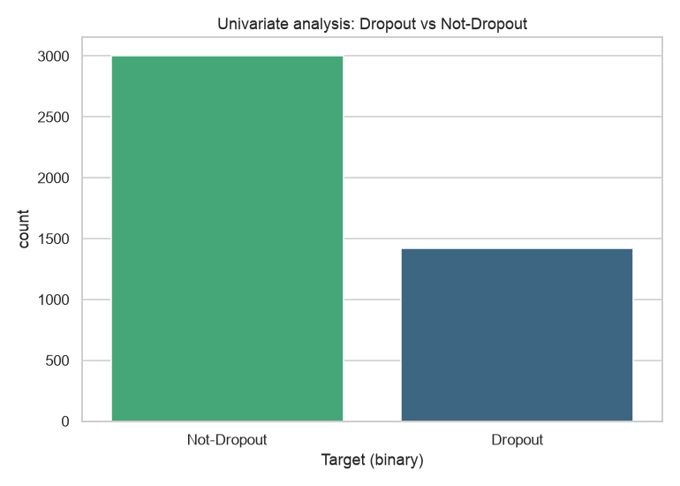
Figure 1: Univariate — target class distribution.
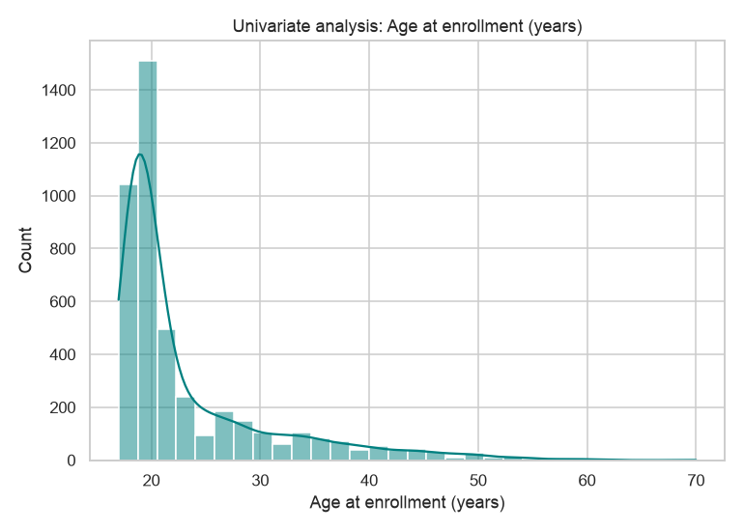
Figure 2: Univariate — age at enrollment (normalized).
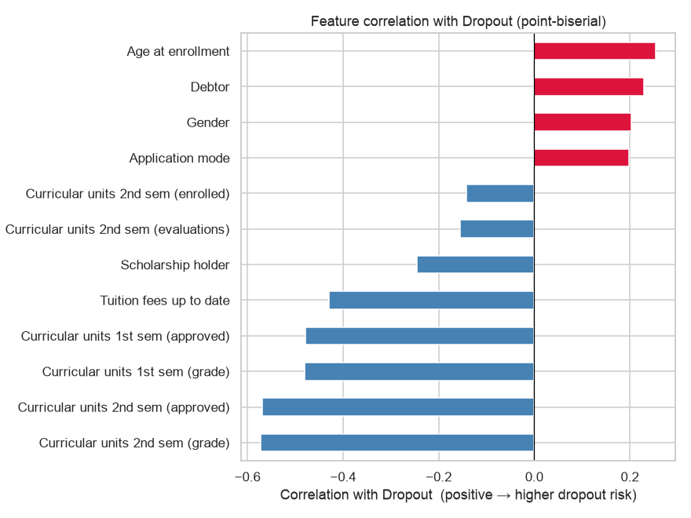
Figure 3: Correlation heatmap of the most relevant features.
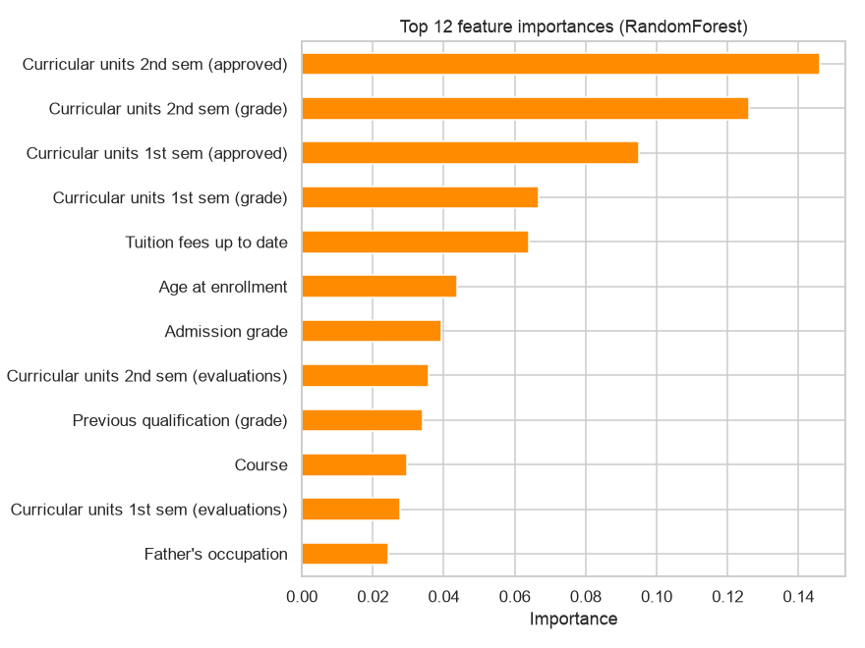
Figure 4: RandomForest feature importance (top 12).
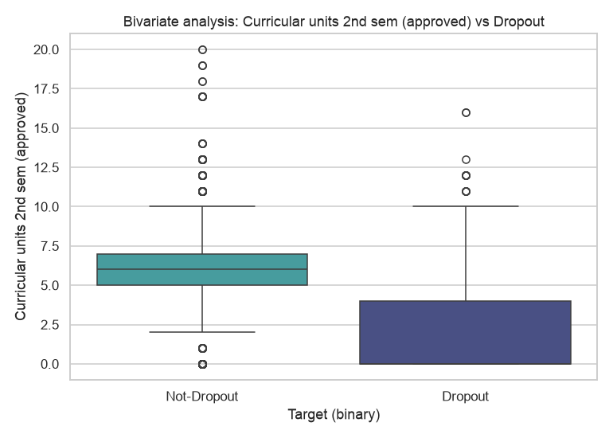
Figure 5: Bivariate — most important feature vs target.
Top features correlated with the target:
- Curricular units 2nd sem (grade): |r| = 0.572
- Curricular units 2nd sem (approved): |r| = 0.57
- Curricular units 1st sem (grade): |r| = 0.481
- Curricular units 1st sem (approved): |r| = 0.479
- Tuition fees up to date: |r| = 0.429

2.4 DataOps — Automation, Scheduling & Cloud Dashboard
The data pipeline is orchestrated with Prefect (flows.py). Tasks ingest → preprocess → EDA are wrapped as Prefect tasks whose logs are streamed to the Prefect dashboard. deploy.py registers a deployment with a 120-second (2-minute) interval schedule, so the workflow runs automatically every 2 minutes.
- Start dashboard: `prefect server start` (http://127.0.0.1:4200).
- Serve 2-minute schedule: `python deploy.py`.
[INSERT SCREENSHOT: Prefect dashboard — Flow Runs page showing successful runs triggered every 2 minutes]
(replace this line with your captured screenshot)
[INSERT SCREENSHOT: Prefect dashboard — Deployments page showing the 'data-pipeline-every-2-min' deployment with its interval schedule]
(replace this line with your captured screenshot)
[INSERT SCREENSHOT: Prefect dashboard — Logs of a flow run showing all activity (ingest / preprocess / EDA log lines)]
(replace this line with your captured screenshot)

3. Sub-Objective 2 — Machine Learning Pipeline (5 marks)

3.1 Model Preparation
Two algorithms suited to tabular classification were selected: Random Forest and XGBoost (ml_pipeline.py). The feature matrix uses all 36 features (continuous imputed, low-cardinality dummy-encoded, high-cardinality Weight-of-Evidence encoded); the target is binary (Dropout=1 vs Not-Dropout=0).

3.2 Model Training (70/30 split)
The dataset is split into 70% training and 30% testing with stratification (3,096 train / 1,328 test rows). Both models are tuned with RandomizedSearchCV; XGBoost uses a deeper, dedicated search (8 hyper-parameters, 30 candidates).
[INSERT SCREENSHOT: terminal output of `python ml_pipeline.py` showing the 70/30 split and 'Trained RandomForest / XGBoost' log lines]
(replace this line with your captured screenshot)

3.3 Model Evaluation & 3.4 MLOps Metrics
Each model is evaluated with four metrics (accuracy, precision, recall, F1 for the Dropout class). MLOps logging writes each metric individually, appends a timestamped record to reports/model_metrics.jsonl, and tracks every run (params, metrics and artifacts) in MLflow under outputs/mlruns.
Model | Accuracy | Precision | Recall | F1-score
RandomForest | 0.8727 | 0.8 | 0.8056 | 0.8028
XGBoost | 0.8818 | 0.8497 | 0.7681 | 0.8069
Table 1: Evaluation metrics on the held-out test set.
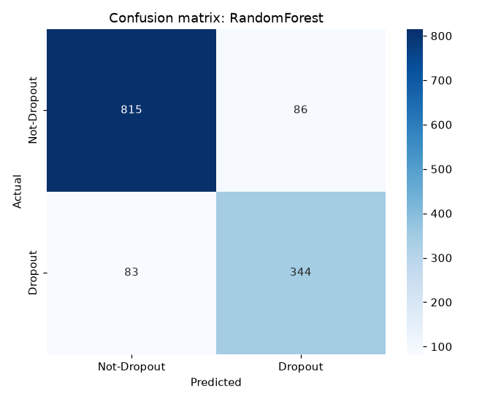
Figure 6: Confusion matrix — Random Forest.
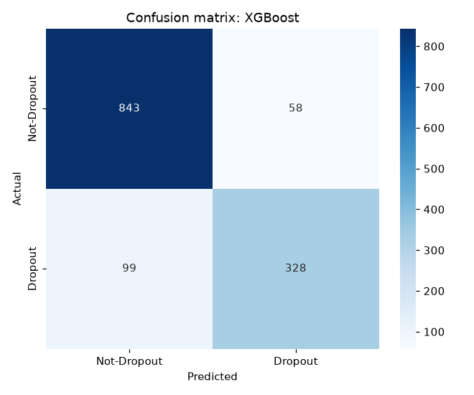
Figure 7: Confusion matrix — XGBoost.
[INSERT SCREENSHOT: terminal output showing the [MLOps] metric log lines for both models]
(replace this line with your captured screenshot)

4. Sub-Objective 3 — API Access (2 marks)
api_access.py uses Prefect's built-in REST API (via the Python client) to retrieve and display key application details. At least four details are presented:
- API health and API version.
- Registered flows (e.g., data-pipeline, student-success-pipeline).
- Deployments with their schedules and tags.
- Recent flow runs and their states (Completed/Failed).
- Work pools (cloud-native execution infrastructure).
Run: `python api_access.py` (with the Prefect server running).
[INSERT SCREENSHOT: terminal output of `python api_access.py` showing the 6 application details retrieved via the built-in API]
(replace this line with your captured screenshot)

5. Conclusion
The application delivers an end-to-end cloud-native solution: an automated, scheduled and logged data pipeline (DataOps); a two-algorithm ML pipeline with monitored metrics (MLOps); and programmatic access to application details through built-in APIs. Random Forest and XGBoost are compared on the binary dropout prediction task (Dropout vs Not-Dropout).

